The data consists of two files Assignment and Leaves.

On Assigment file there is a data of projects (their Start and End date), the project name, manager and people assigned to certain projects. On leaves file there are only the employees that will have holidays (we should care about Start(Leave) date and End(Leave) date, the ‘Date’ column – is the column where there is info when the holiday was put into system – we should not care about “Date’ column). The data should be joined in Tableau – Assignment left join Leaves and the common key is **Product/Resource reference** from Assignment and **Resource reference** from Leaves.

The aim of the dashboard is:

1. For the managers to be able to find their projects and to find out whether any people in next 2-3 months will be on holidays
2. For managers to be able to check if they can agree to somebody’s holiday based on the holidays they already have in the system.

I’d like to have there certain filters:

* Company (include only Astek and Roche)
* Manager
* Active/Inactive projects – active are these that have already started but have not finished. Inactive is what has already finished or has not started yet (we can use the NOW() function for that – see below)
* Based on Parameter ‘Choose date’ filter of dates we want to check for (September and October dates)

Also there should be some indicator for the manager that a project is in danger – for example the project should be in red when there is less than 50% of employees at a time.

CHARTS:

1. I’d like to have there a **Gantt Chart** of projects, sth like that

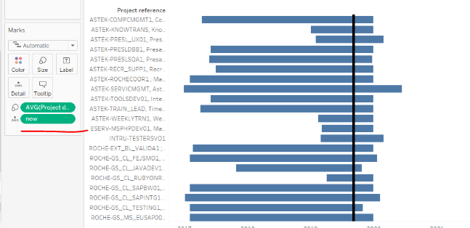

With the function NOW() indicating as a reference line where we are at the date now.

We should change the Project reference name, because it consists of some long names in front f.e. ROCHE-RDR_CL_FRONTE2, RDR Cloud Frontend (old FECOMO1) we should change to R, RDR Cloud Frontend (old FECOMO1) -> here R in the front is the indicator that it is Roche and A would be for Astek.

I’d like also to have on this chart the **number of employees assigned to this project** (should take that from Assignment sheet) and on the right of this chart (or maybe applied to this chart on dual axis) also some **indicators when there is a holiday planned** for people from this project

For example sth like that

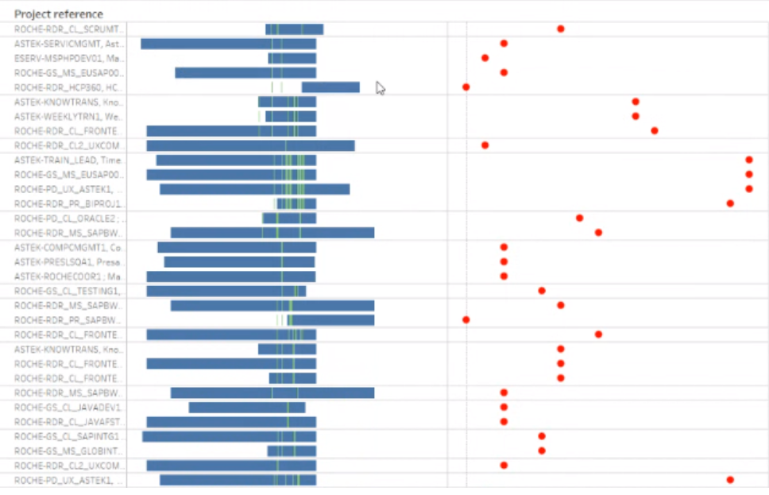

Here this chart should work as a filter for other charts and manager should be able to click on certain project to get some more details on further charts

2) After clicking on a project from chart 1 we should proceed to a detailed info on a certain project:

Here should be a chart of certain employees that are involved in certain project and the length of their holidays as well as a total number of employees that are involved in this project. Should add some calculation of how much % of total employees will be absent due to holidays for that project and if it is more than 50% the project should be marked as in danger)

3) Some other chart showing the detailed data (??)

4) On separate dashboard the same thing, but from a perspective of a single employee that goes to the manager and wants to ask for a holiday leave. The manager should look that person up in a filter (based on a Calculation Field : Full Name constructed from **Product/Resource - First Name**

and **Product/Resource - Last Name** from Assignment table or employee id - **Product/Resource reference)** see which of his project this person is currently working on, check what are the planned holidays of other employees for this period and what is a total head count for that particular project and based on that information make a decision if he/she should be able to get the holiday leave.